

PROJECT CHARTER

**Version1.1**

**Quốc Nhân**

**05/10/2019**

**VERSION HISTORY**

|  |  |  |  |  |  |
| --- | --- | --- | --- | --- | --- |
| **Version #** | **Implemented**  **By** | **Revision**  **Date** | **Approved**  **By** | **Approval**  **Date** | **Reason** |
| 1.0 | Quốc Nhân | 05/10/2019 |  |  | Create document project charter version 1.0 |
| 1.1 | Quốc nhân | 05/10/2019 |  |  | Update project charter v1.1 |
|  |  |  |  |  |  |
|  |  |  |  |  |  |

Table of Contents

1. Introduction 3

2. OBJECTIVES 3

3. scope 3

4. CONSTRAINTS, ASSUMPTIONS AND RISKS 3

4.1 Constraints 3

4.2 Assumptions 3

4.3 Risks 3

5. PROJECT STAKEHOLDER 3

6. ROLES AND RESPONSIBILITY 3

7. DELIVERABLES 3

8. ASSIGN ROLE 3

# Introduction

* For now, housing demand is a major problem for people across the country, so landlords are looking to provide housing through the real estate app.
* Real Estate App, built for internal users to manage projects, manage statistics, reports and many other functions.
* The App also helps employees know more about information needed to know about the real estate industry or apply for leave, business trips as well as track information from superiors.
* The app also helps customers find the land they want to search by entering their parameters and returning the corresponding parcel on the app
* The app also helps customers find the plot of land they want to search by entering their parameters and returning information about plot of land on the app.

# Objectives

The Real Estate App helps interactors receive the information they need and is divided into two phases:

* Phase 1: Internal.
  + - Account management: Login, logout, display account information, search for personnel, display personnel list, show company chart, display company policies, add accounts, delete accounts, edit accounts, accounts classification.
    - Project management: Show project list, search for the project, show project details, add project, edit project, project classification.
    - Statistical management, reporting: Displaying business results, displaying business results graph, display table comparing business results.
    - Business trip manager: Sign up for business, browse business trip, business trip history.
    - Management quit: Register to quit your job, approval of leave, history of leave.
    - Other functions: Birthday staff notification.
* Phase 2: Customer.

# Scope

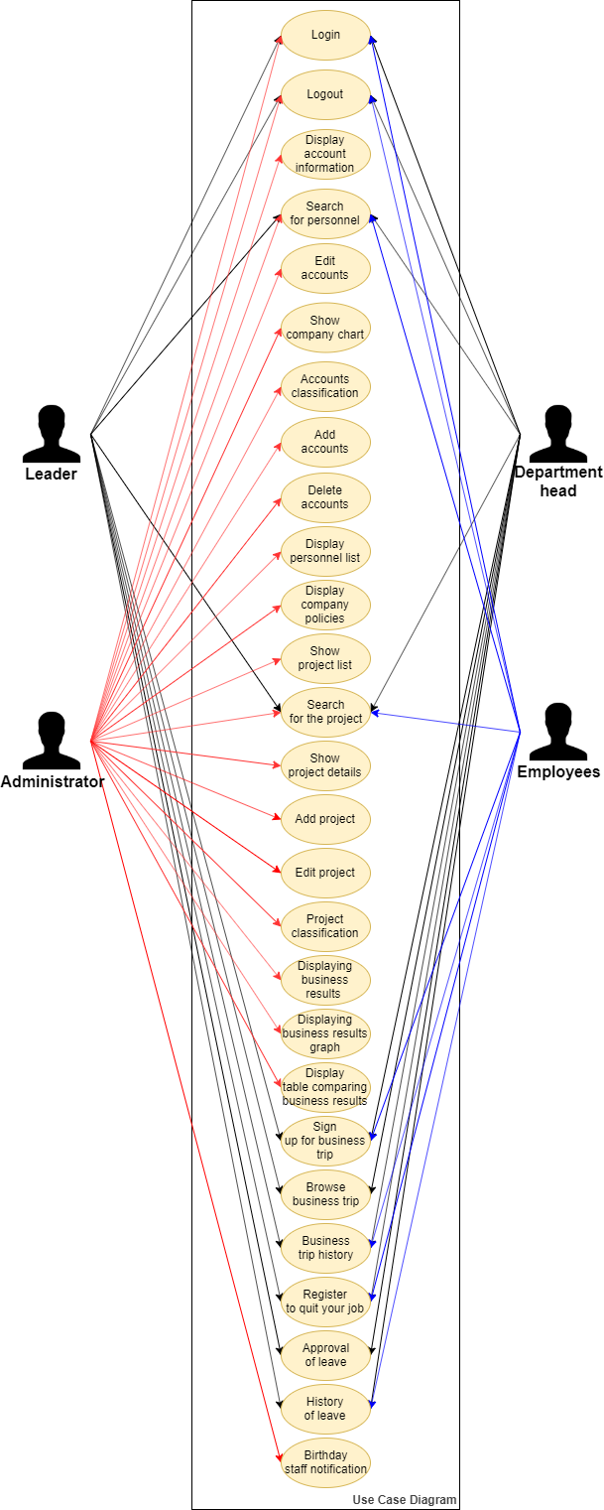

# Constraints, assumptions and risks

## Constraints

Development within 30 weeks

Technical constraints:

* Programming Languages: React native (Java script) on Android & IOS.
* Database:

## **Assumptions**

* Will be able to make the first phase requirements of customers within 1 and a half months.
* Will run the app real estate on QGIS for customer.
* Access data information plot of land quickly and accurately for customer.
* Quick and accurate access to statistical data.
* Manage internal information completely by software.

## Risks

Spends a lot of time learning how to use software on app Android or IOS and other services such as software installation, maintenance.

# Project stakeholder

|  |  |
| --- | --- |
| **Stakeholder** | **Project Completion/Success** |
| **Customer** | Product is delivered follow each phase:  Phase 1: Completed within 6 weeks.  Phase 2: Completed within 24 weeks. |
| **Mentors** | Consultant for project team until Project completed.  Evaluate after each phase. |
| **Hello World Team** | Develop App real estate within 30 weeks. |

# Roles and responsibility

|  |  |  |
| --- | --- | --- |
| **No** | **Roles** | **Responsibilities** |
| 1 | Project Manager | * Prepare reports, records of work accomplishments and information about management. * Report to the mentor periodically about team activities, progress, problems... * Organize training sessions for team member when needed. * Create a trust environment in team, open communication between members and creative thinking... * Provide a vision of the project objectives for team. * Motivate and inspire team members. |
| 2 | Requirement Leader | * Communicating with customer to gather the requirement. * Assigning and arranging the tasks that related with requirement. * Creating and supporting for completing Concept Operation document, URD document and SRS document |
| 3 | Architecture Leader | * Creating models, component and interface specification documents, validating the architecture against requirements and assumptions. * Communicating with Requirement Team for Architecture Driver Document. * Creating and supporting for completing Architecture Design Document. |
| 4 | Design Leader | * Communicating with architect leader for completing Software Design Specification Document * Responsibility for supporting team members analyzes functions into detail (Database). |
| 5 | Implement Leader | * Be responsible for the technical issues for the project. * Master in technology will be applied to the project suit with the system’s architecture * Responsible for the Implementation phase. |
| 6 | Testing Leader | * Understanding and documenting testing requirements, provide test estimates, create and review test cases, execute and review test results, create and submit test reports to stake holders. |

# Deliverables

|  |  |  |  |  |
| --- | --- | --- | --- | --- |
| **No.** | **Deliverable** | **Primary Producer** | **Method** | **Remark** |
|  | Concept of Operation (Con-Op) | Hello World Requirement Team | .doc or .pdf files | Refine, review current business processes and proposed business processes |
|  | Software Requirement Specification (SRS) | Hello World Requirement Team | .doc or .pdf files | Refine, review and acquire Requirements Specification Sign-off |
|  | Architecture Driver Document (ADD) | Hello World Architecture & Design Team | .doc or .pdf files | Document Architecture driver specification and constraints of App real estate |
|  | Software Architecture Document | Hello World Architecture & Design Team | .doc or pdf files | Document architecture of app ‘real estate’ follow 3 perspectives  Document rational of each perspective |
|  | System Design Specification (SDS) | Hello World Architecture & Design Team | .xlsx files | Document all architecture design of App real estate |
|  | System Test Plan and Result | Hello World Testing Team | .xlsx files | Plan for verifying app ‘real estate’ working as designed while meeting user’s requirement. |
|  | Acceptance Test Plan and Result | Hello World Testing Team | .doc or .pdf files | Plan for validating app ‘real estate’ meeting customer’s needs and accepted by customer |
|  | Test Report | Hello World Testing Team | .doc or .pdf files | Document test result |
|  | Bug Report | Hello World Testing Team | .doc or .pdf files | Document bugs that found |
|  | App ‘real estate’ | Hello World Development Team | .exe file | System application, source code, databases |
|  | User guide | Hello World Requirement Team | .doc or pdf files | Assisting insiders & Users to use the App ‘real estate’ |
|  | Installation guide | Hello World Requirement Team | .doc or pdf files | Assisting insiders & Users to install the App ‘real estate’ |
|  | Team Charter Document | Hello World Team | .doc or pdf files | Information about Hello World team |
|  | Project Charter | Hello World Team | .doc or pdf files | Document scope, stakeholders, human resource initial project |
|  | Project Plan | Hello World Team | .doc or pdf files | Include all of the key elements of project planning |
|  | Detail Plan | Hello World Team | .doc or pdf files | Include detail tasks of the project |
|  | Project reflection paper | Hello World Team | .doc or pdf files | Documented insights from the project, problems and how they were solved, other information worthy of passing on to Steering |
|  | Weekly report | Team leader | .pptx files | Report each week to mentor about project status |
|  | Individual Weekly report | All member | .pptx files | Report each week to project manager about work status. |

# Assign role

|  |  |  |
| --- | --- | --- |
| **Role** | **Name** | **Responsibility** |
| Project Manager | Đạt Huỳnh | Planning and Monitoring and Control Process |
| Requirement Leader | Như Phương | Collect, Analyze and Controlling in Requirement Phase |
| Architecture and Design Leader | Quốc Nhân | Analyze System, Controlling Architecture Phase |
| Implementation Leader | Quang Vương | Code and Deploy product to customer |
| Test Leader | Anh Minh | Planning, Develop Test Case and Execute Test. |
| Develop Team | Đạt Huỳnh, Quốc Nhân, Quang Vương, Anh Minh, Như Phương | Project development |
| Customer |  | Give requirement, baseline requirement, contact develop team. |